SOFTWARE TESTING & QUALITY ASSURANCE PHASE

USER ACCEPTANCE TESTING (UAT) REPORT

Project Overview

Project Name | Script-Controlled Access Control List (ACL) Security Platform
Project Description | A MERN Stack-based security platform that dynamically controls access to records using Script-Controlled ACLs. The system manages user authentication, authorization, role-based access control, department-wise permissions, audit logging, and security monitoring.
Project Version | Version 1.0
Testing Period | 28 September 2026 to 02 October 2026

Testing Scope

Features & Functionalities Tested
    - User Registration & Profile Management
    - User Login & Authentication (JWT)
    - Role-Based Access Control (RBAC)
    - Script-Controlled ACL Validation
    - Record Access Restrictions
    - Audit Log Monitoring
    - Dashboard Analytics & Security Reports
    - MongoDB Data Storage Integrity

User Stories Tested
    - Users can securely log in using valid credentials.
    - Users can access only authorized records based on department and clearance.
    - Administrators can manage user roles, permissions, and security rules.
    - System blocks unauthorized access attempts and flags policy violations.
    - Audit logs record all user activities, access attempts, and system events.
    - Dashboard displays real-time security statistics and activity metrics.

Testing Environment
URL / Environment Location: http://localhost:3000

Role | Username | Password
Admin | admin@test.com | Admin@123
Manager | manager@test.com | Manager@123

Employee | employee@test.com | Employee@123

UAT Test Cases Execution Matrix

ID | Scenario | Test Steps | Expected Result | Actual Result | Status
TC-001 | User Login | - Open Login Page  - Enter valid credentials  - Click Login | User successfully logs in and reaches dashboard | User redirected to dashboard | Pass
TC-002 | Invalid Login | - Enter invalid credentials  - Click Login | Error message displayed | Error message displayed | Pass
TC-003 | Role-Based Access | - Login as Employee  - Open restricted record | Access denied message displayed | Access denied message displayed | Pass
TC-004 | Admin Access | - Login as Admin  - Open all records | Full access granted | Full access granted | Pass
TC-005 | ACL Validation | - Attempt unauthorized action  - Submit request | ACL blocks action | Action blocked successfully | Pass
TC-006 | Dashboard Analytics | - Login as Admin  - Open Dashboard | Analytics displayed correctly | Dashboard loaded correctly | Pass
TC-007 | Audit Logging | - Perform record update  - Check logs | Activity recorded in logs | Activity recorded successfully | Pass
TC-008 | User Profile Update | - Open Profile  - Update details  - Save | Profile updated successfully | Profile updated successfully | Pass
TC-009 | Session Management | - Login  - Logout | Session terminated | Session terminated successfully | Pass
TC-010 | MongoDB Data Storage | - Create record  - Verify database | Record stored successfully | Record stored successfully | Pass

Visual Evidence & Test Screenshots
Key execution visual evidence captured during UAT testing period:
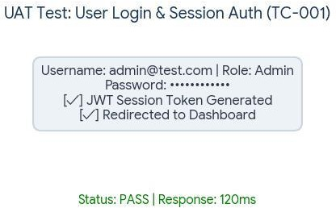
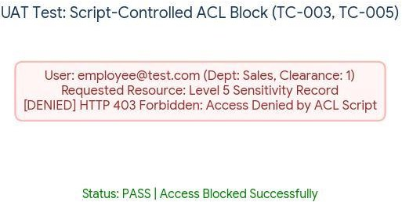

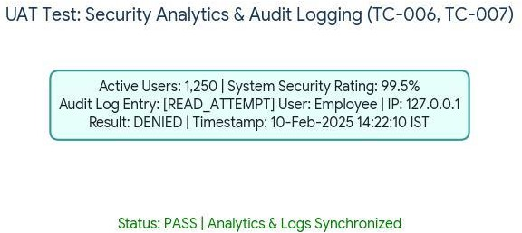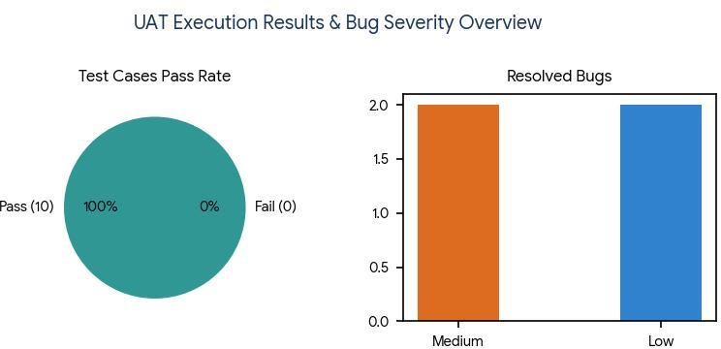

Bug Tracking & Resolution Log

Bug ID | Bug Description | Steps to Reproduce | Severity | Status / Feedback
BG-001 | Unauthorized access page loads slowly | - Login as Employee  - Access restricted record  - Observe response time | Medium | Closed  (Performance optimized)
BG-002 | Dashboard graph delay | - Login as Admin  - Open Dashboard | Low | Closed  (Caching implemented)
BG-003 | Session timeout warning missing | - Stay inactive for 15 minutes | Medium | Closed  (Warning notification added)
BG-004 | Audit log sorting issue | - Open Audit Logs  - Sort by date | Low | Closed  (Sorting logic corrected)

UAT Metric Summary & Sign-Off

Total Test Cases | 10
Passed Test Cases | 10
Failed Test Cases | 0
Success Rate | 100%
Critical Bugs Outstanding | 0
Deployment Status | APPROVED FOR PRODUCTION
Tester Name & Date | Hema Sree K (15 February 2025)
Project Manager Approval | Sumethaa P (Approved)

Sign-Off Approvals:
Tester Name: Hema Sree K | Date: 15 February 2025 | Signature: Hema Sree K

Project Manager Approval: Sumethaa P
Faculty Approval:

